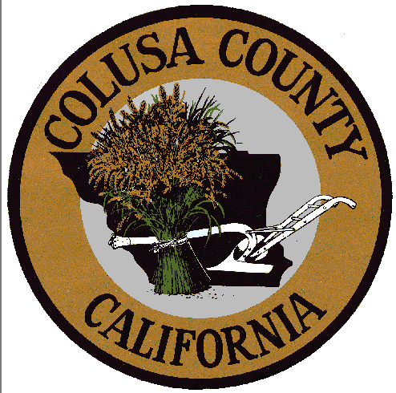

Notice of Meeting
Cancellation

BOARD OF SUPERVISORS
Tuesday, July 24, 2018
9:00 a.m.
Board Chambers
546 Jay Street, Suite 108
Colusa, CA 95932

